.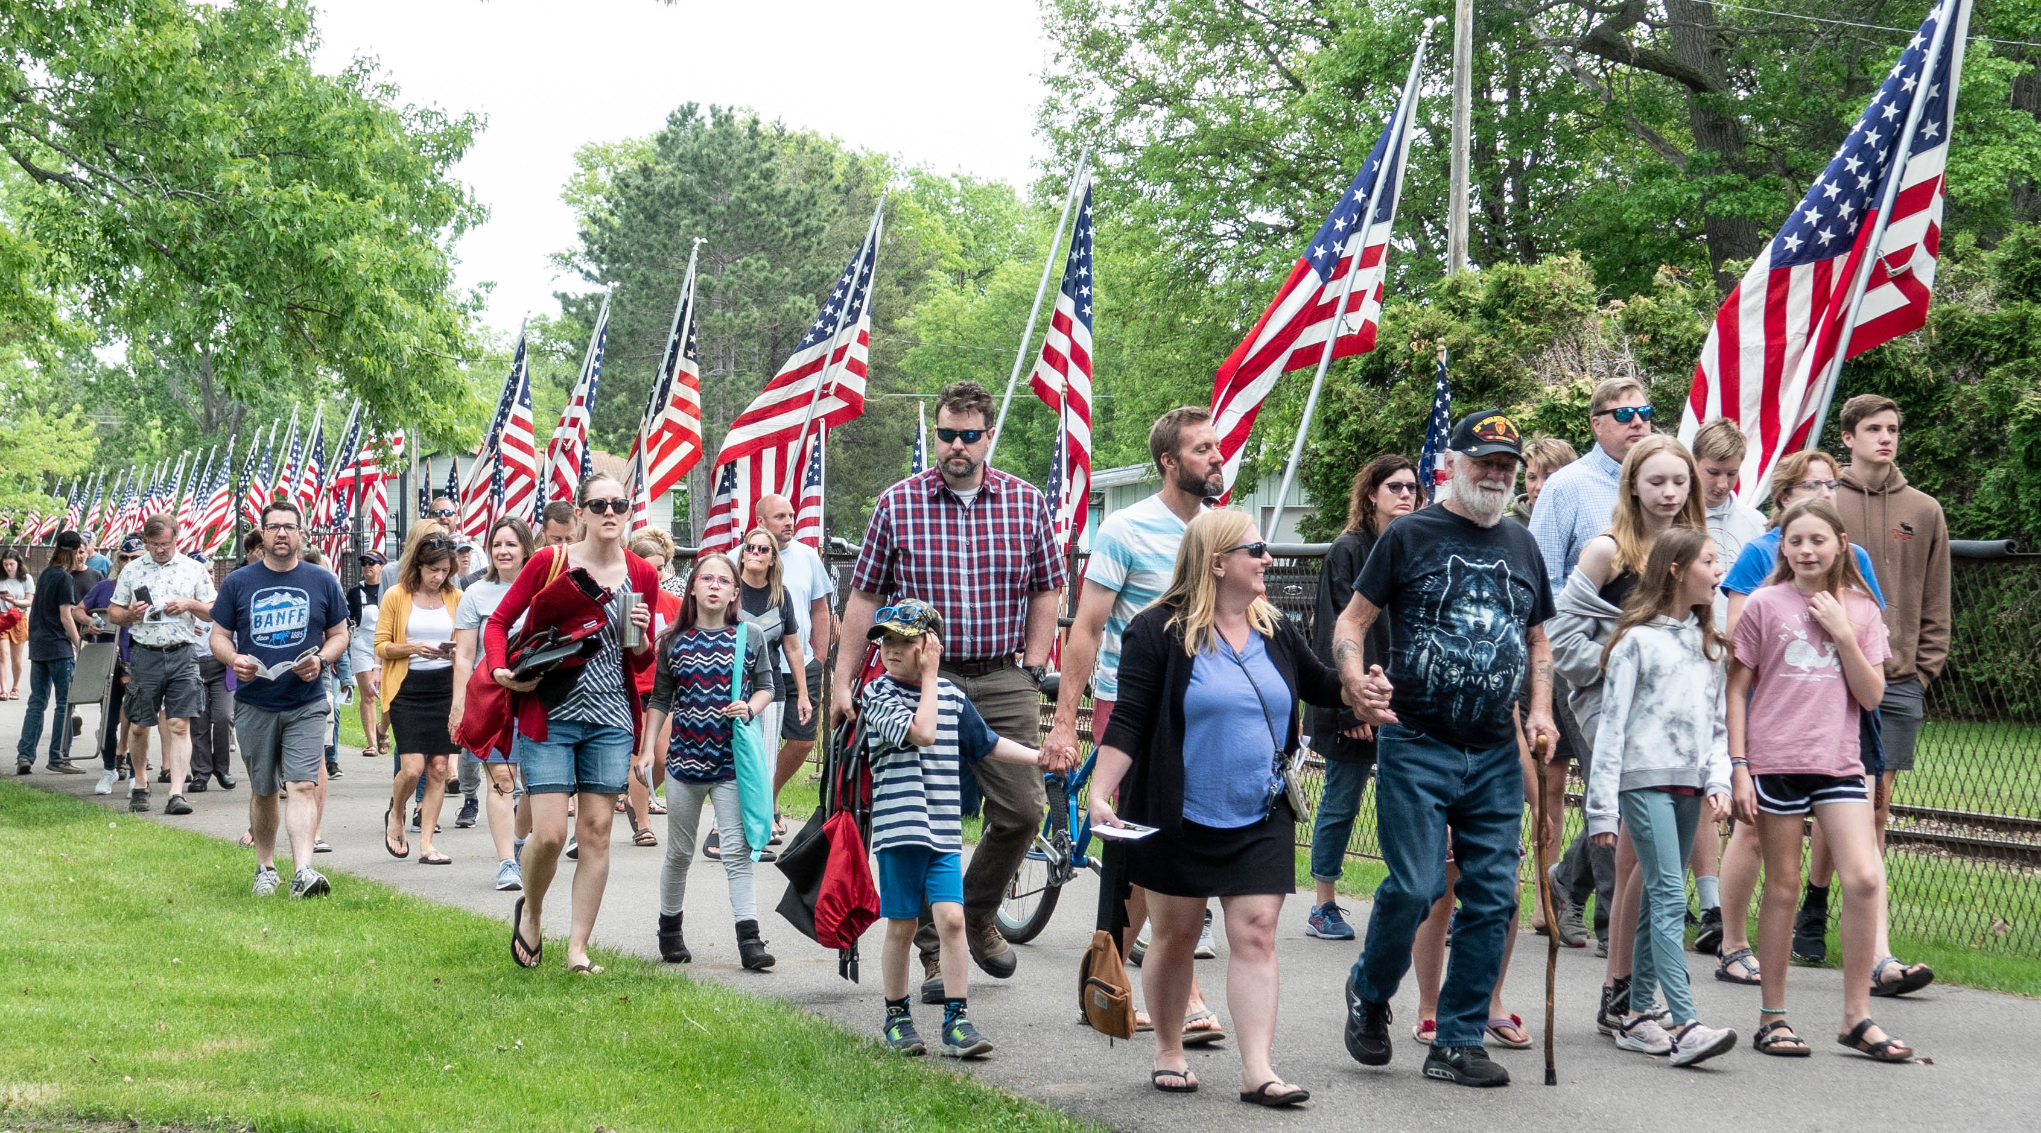 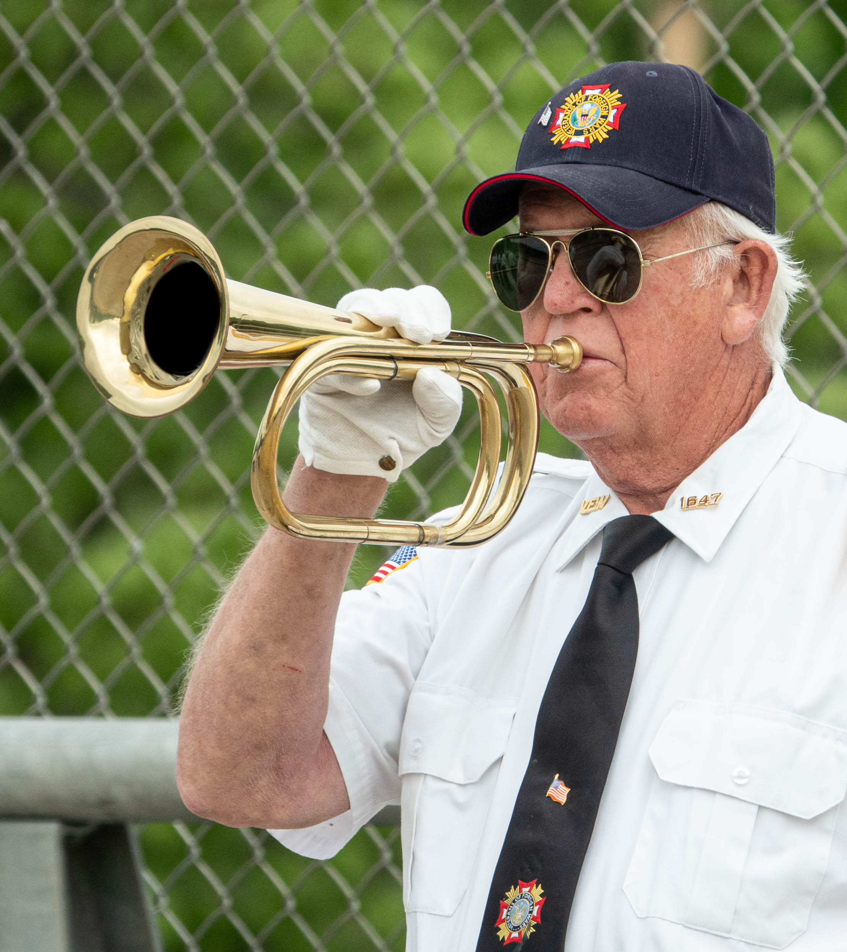
Brainerd Memorial Day Ceremonies
Monday, May 27, 2024
.
9:00 am A wreath thrown in the Mississippi River at the Laurel Street Bridge.

9:45 am A short ceremony at the All-Veterans Memorial, 4th and Laurel St.
10:30 am A parade on 3rd Avenue NE to Evergreen Cemetery, 1105 3rd Ave. NE.
11:00 am The main ceremony at Evergreen Cemetery with the High School Band.
In case of rain, the 11 am ceremony will be at the Brainerd National Guard Armory at 1115 Wright Street in south Brainerd.
Lunch by the Brainerd Elks and the Brainerd American Legion, at 708 Front Street, until 1 pm for veterans and their families. Donations will be accepted.
3:00 pm Taps Across America at the All-Veterans Memorial, 4th & Laurel St.
For those who can’t attend in person, the Evergreen Cemetery event will be available mid-evening at: https://www.facebook.com/brainerdmemorialday
Details at: https://www.brainerdvfw.org/memorialday.html
Questions? Mark Persons, 218-829-1326 teki@mwpersons.com

